## 

## A Project Report

## On

### 

**GROCERY APP -USING KOTLIN**

**IN ANDROID STUDIO**

**SUBMITTED BY**

**C.APOORVA.A.KAMATH**

**UNDER**



**DATE OF SUBMISSION: 18-SEPT-2022**

**INDEX**

**CHAPTER 1: Introduction**

**1.1 Abstract.................................................................................1**

**1.2 Objective...............................................................................1**

**CHAPTER 2: Background & Diagrams**

**2.1 Background...........................................................................2**

**2.2 Studies....................................................................................2**

**2.3 Challenges..............................................................................2**

**2.4 Context Diagram...................................................................3**

**CHAPTER 3: Requirements**

**3.1 Software................................................................................4**

**3.2Hardware...............................................................................4**

**CHAPTER 4: Implementation and Designing**

**4.1 Home Page.............................................................................5**

**4.2 Pop Up....................................................................................5**

**CHAPTER 5: Conclusion and Future Scope**

**5.1 Conclusion..............................................................................6**

**5.2 Future Scope..........................................................................6**

Page No 1

**CHAPTER-I**

**1.1 Abstract:**

An Android app is a software application running on the Android platform. Because the Android platform is built for mobile devices, a typical Android app is designed for a smartphone or a tablet PC running on the Android OS.

[Kotlin](https://www.geeksforgeeks.org/introduction-to-kotlin/) is a cross-platform programming language that may be used as an alternative to Java for Android App Development. Kotlin is much simpler for beginners to try as compared to Java and this **Kotlin Android Tutorial** can also be used as an ‘entry point’ for Android App Development. Kotlin is sponsored by Google, announced as one of the official languages for Android Development in 2017. [Kotlin programming language](https://www.geeksforgeeks.org/kotlin-programming-language/) is multi-platform, i.e. easily executable on a Java Virtual Machine.

**1.2 Objective:**

The main goal of the project is to develop an app which can add the grocery item to the list and delete the item.It can register the *item name

*number of items

*cost of each item

*total cost

To develop a reliable system , I have some specific goals such as:

* Develop a system such that user can add item details like product name,product Quantity and Product Price
* Develop a database room which is used to store the user data which already added by the user in cart and user can also remove the previous added item in cart
* Develop the good UI design which user friendly to user
* Dvelop the good UI which is supported for all android devices

Page No 2

**CHAPTER 2**

**Background & Diagrams**

**2.1 Background:**

Grocery app is a project that will help the user or admin to store the list of items in sequence order.The user can add or delete the item as per his convenience

* UI DESIGN IN ANDROID PLATFORM
* ANDROID APPLICATION DEVELOPMENT
* DATABASE CONNECTION TO STORE USER DATA

**2.2 Studies:**

* Design user friendly environment
* Connecting database
* Add material icon for good UI
* Create the vectors and Material Colours
* Navigation of user action from one page to another page

**2.3 Challenges:**

working with database friendly UI design for UXGradle and SDK settings

Page No 3

**2.4 Context Diagram:**

Use Care Diagram of Admin

**ADMIN**

Page No 4

**CHAPTER 3**

**REQUIREMENT OF COLLECTION ADN ANALYSIS:**

**3.1 SOFTWARE:**

The Software Package is Developed Using Kotlin and Android Studio, basic Sql Commands Used to Store the Database

Operating System: Windows 11

Software: Kotlin and Java

Emulator: Pixel 5 (Api 31)

**3.2 HARDWARE:**

RAM : 8GB RAM

ROM : 20GB

Page No 5

**CHAPTER 4**

**4.1 HOME PAGE & LIST ITEMS:**

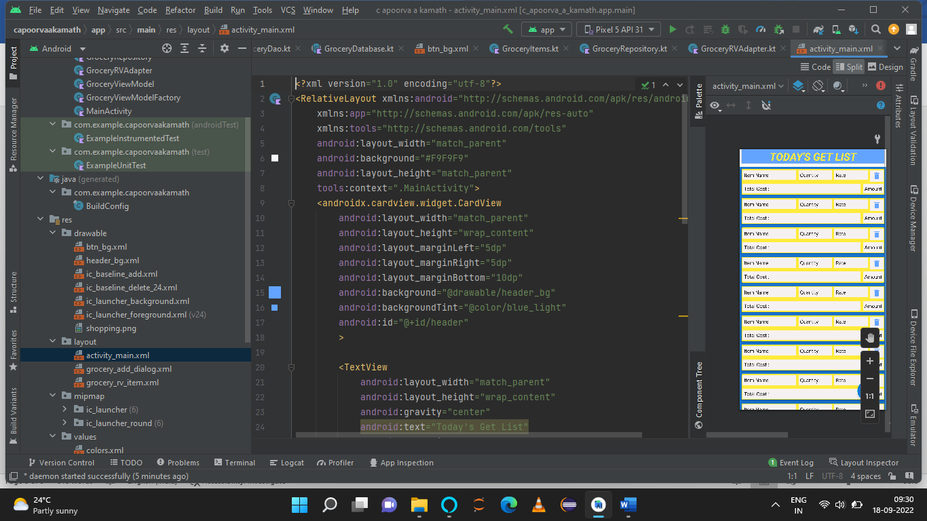

**4.2 POP UP PAGE**

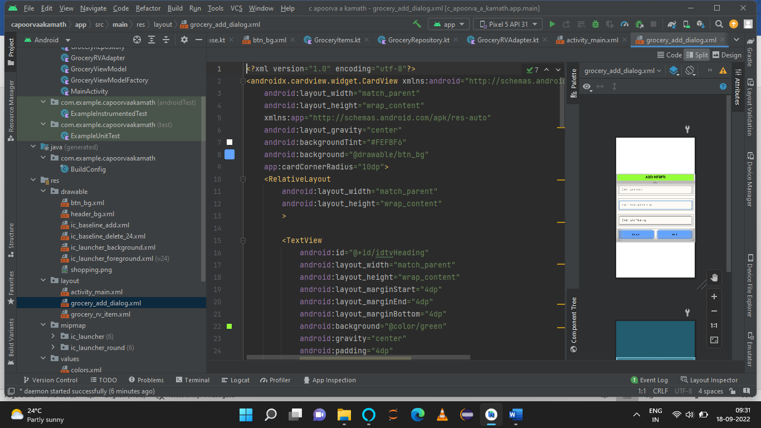**:**

Page No 6

**CHAPTER 5**

**5.1 Conclusion:**

This application will help to store the list of items date include name price and quantity.most of shopping admins want to store the his data in list, the application is very help full for them.not only in shops and admins also helpful for user what they buy and what they want to buy.

**5.2 Future Scope:**

This application help to store the list of items by Admin .In Future we can also add user panel which is add by user required item that are submitted to admin

The Feature are:

* Add User Panel
* Add Admin Panel
* Provide Login authentication
* Add image to user product and rating